MIDAS CORE
Financial Transaction Processing Service
Product & Engineering Specification
Product Requirements · Technical Requirements · System Interaction Flow · Implementation Plan

Document Owner | Engineering — Midas Core Team
Program | Forage × JPMorgan Chase Software Engineering Virtual Internship
Document Type | Consolidated PRD / TRD / System Interaction / Implementation Plan
Version | 1.0
Status | Draft — For Review
Date | September 2026
Classification | Internal Use — Simulation Project

Document Control

Revision History
Version | Date | Author | Summary of Changes
0.1 | Sep 2026 | Engineering (Draft) | Initial project understanding notes captured from program brief.
1.0 | Sep 2026 | Engineering | Consolidated PRD, TRD, System Interaction Flow, and Implementation Plan; added architecture, sequence and data model diagrams; added risk register and RAID log.

Approval
Role | Name | Status | Date
Technical Reviewer | TBD | Pending | —
Product Owner | TBD | Pending | —

Related Documents
- Program scaffold repository — https://github.com/vagabond-systems/forage-midas
- Original project understanding notes — Project_Understanding_Draft.md (source input for this document)

Table of Contents
1. Executive Summary 5
2. Part I — Product Requirements Document (PRD) 6
2.1 Purpose 6
2.2 Background 6
2.3 Goals and Objectives 6
2.4 Scope 6
2.5 Stakeholders and Actors 7
2.6 Functional Requirements 7
2.7 Non-Functional Requirements 8
2.8 Assumptions 9
2.9 Constraints 9
2.10 Success Metrics and Acceptance Criteria 9
2.11 Future Enhancements (Out of Current Scope) 9
3. Part II — Technical Requirements Document (TRD) 11
3.1 Architecture Overview 11
3.2 Technology Stack 11
3.3 Component Design 12
3.4 Data Model 13
3.5 API Specification 13
3.6 Configuration Reference (application.yml) 14
3.7 Testing Strategy 14
3.8 Security Considerations 14
3.9 Risk Register 15
4. Part III — System Interaction Flow 17
4.1 End-to-End Interaction Sequence 17
4.2 Transaction State Model 17
4.3 API Consumer Experience — Success Path 18
4.4 API Consumer Experience — Exception Paths 18
4.5 Balance Query — Concurrent Operation 18
5. Part IV — Implementation Plan 19
5.1 Delivery Approach 19
5.2 Work Breakdown Structure 19
5.3 Timeline 19
5.4 Roles and Responsibilities (RACI) 20
5.5 Definition of Done 20
5.6 Deployment and Environment Strategy 20
5.7 RAID Log 20
5.8 Rollback and Contingency 21
6. Appendices 22
6.1 Glossary 22
6.2 Reference Documents 22
6.3 Key Domain Classes 22
6.4 Software Engineering Principles Applied 22

1. Executive Summary
Midas Core is the backend transaction-processing service at the center of the Midas platform. It ingests financial transaction events from an upstream message queue, validates and persists them against account balances held in a relational database, enriches each transaction with an incentive amount computed by an independent external service, and exposes an HTTP API through which current account balances can be queried.
This document consolidates the four artifacts a delivery team would normally maintain separately for a service of this kind: a Product Requirements Document (PRD) describing what the system must do and why; a Technical Requirements Document (TRD) describing how it is built, including architecture, data model, API contracts and engineering risk; a System Interaction Flow section, which substitutes for a traditional UI/UX flow given that Midas Core is a headless backend service with no graphical interface; and an Implementation Plan describing delivery phasing, timeline, ownership and definition of done.
Midas Core is being delivered as five incremental engineering tasks: project setup, Kafka integration, database and validation logic, external Incentive API integration, and REST API exposure. Each task is independently testable and builds on the previous one, producing a fully functional, end-to-end pipeline by the final task.
Scope note
This document treats Midas Core as if it were heading into a professional engineering review, which means it also surfaces gaps that exist in the current scaffold-level design — for example, the absence of authentication, idempotency handling, and monetary-precision safeguards. These are flagged explicitly in Section 4.9 (Risk Register) rather than glossed over, since a specification that hides known weaknesses is worse than no specification at all.

2. Part I — Product Requirements Document (PRD)

2.1 Purpose
This PRD defines the functional scope, stakeholders, and success criteria for Midas Core — the transaction ingestion, validation, and balance-management service within the wider Midas platform. It establishes what the system must accomplish from a product and business standpoint, independent of implementation detail, which is addressed separately in the TRD (Section 3).

2.2 Background
Financial institutions process high volumes of transactions that must be validated, recorded, and reflected in account balances with strong consistency guarantees. Midas Core simulates this responsibility inside a bounded, five-stage engineering exercise: it must decouple transaction intake from processing using an asynchronous message broker, enforce business validation rules before mutating financial state, integrate with an independently owned external service without controlling that service's internal logic, and expose the resulting account state through a queryable API.

2.3 Goals and Objectives
- Reliably ingest transaction events published by upstream trading/frontend systems without coupling producers to Midas Core's internal availability.
- Guarantee that only valid transactions affect account balances, and that invalid transactions leave no trace in persisted state.
- Incorporate a per-transaction incentive amount computed by an independently maintained external service, without that service's internal logic being a dependency of Midas Core's own correctness.
- Provide a simple, queryable view of current account balances to downstream consumers.
- Demonstrate an architecture that separates concerns cleanly enough that any one integration point (queue, database, external API, REST layer) could be modified or replaced with limited impact on the others.

2.4 Scope

In Scope
- Consumption of transaction messages from a Kafka topic.
- Validation of transactions against existing user accounts and available sender balance.
- Persistence of valid transactions and resulting balance changes to a relational database.
- Synchronous integration with an external Incentive API to compute and apply incentive amounts.
- A REST endpoint for querying a single user's current balance.

Out of Scope
- User registration, authentication, or account-management workflows (accounts are assumed to pre-exist).
- A graphical user interface of any kind — Midas Core is a headless backend service (see Section 5).
- Multi-currency support, transaction reversal/refund flows, and batch/bulk transaction submission.
- Production-grade security (authentication, authorization, encryption in transit) — explicitly called out as a gap in Section 4.9, not assumed to be handled implicitly.
- Horizontal scaling, multi-instance deployment, and production observability tooling.

2.5 Stakeholders and Actors
Actor | Description | Interest / Interaction
Transaction Producer | Upstream trading or frontend systems. | Publishes transaction events to Kafka; requires the topic contract to remain stable.
Midas Core (this service) | The system under specification. | Consumes, validates, persists, enriches, and exposes transaction and balance data.
Incentive API | Independently owned external service. | Receives a transaction, returns an incentive amount; contract-only dependency.
API Consumer | Any client querying account state. | Calls GET /balance to retrieve a user's current balance.
Engineering / Review Team | Builders and reviewers of Midas Core. | Owns correctness, test coverage, and architectural quality.

2.6 Functional Requirements
Each functional requirement is traceable to one of the five delivery tasks described in Section 6.2.
ID | Requirement | Source Task
FR-01 | The system shall consume transaction messages from a Kafka topic whose name is externally configurable via application.yml. | Task 2
FR-02 | The system shall deserialize each incoming Kafka message into a Transaction domain object. | Task 2
FR-03 | The system shall validate a transaction as valid only if: (a) the sender ID corresponds to an existing user, (b) the recipient ID corresponds to an existing user, and (c) the sender's balance is greater than or equal to the transaction amount. | Task 3
FR-04 | The system shall discard invalid transactions with no persisted record and no balance mutation. | Task 3
FR-05 | The system shall persist every valid transaction as a TransactionRecord entity, linked to its sender and recipient User entities. | Task 3
FR-06 | The system shall debit the sender's balance by the transaction amount upon successful validation. | Task 3
FR-07 | The system shall submit every valid transaction to the external Incentive API via a synchronous HTTP POST request. | Task 4
FR-08 | The system shall capture the incentive amount returned by the Incentive API and store it on the corresponding TransactionRecord. | Task 4
FR-09 | The system shall credit the recipient's balance by the transaction amount plus the incentive amount. | Task 4
FR-10 | The system shall not deduct the incentive amount from the sender's balance under any circumstance. | Task 4
FR-11 | The system shall expose a GET /balance endpoint accepting a userId request parameter. | Task 5
FR-12 | The system shall return the requested user's current balance, serialized as JSON, when the user exists. | Task 5
FR-13 | The system shall return a balance of zero for a userId that does not correspond to an existing user, rather than an error response. | Task 5
FR-14 | The REST controller and the Kafka listener shall operate concurrently within a single Spring Boot process, listening on port 33400. | Task 5

2.7 Non-Functional Requirements
ID | Category | Requirement
NFR-01 | Consistency | Financial state changes (balance debits/credits) must be committed atomically with the transaction record — partial writes are not acceptable.
NFR-02 | Testability | Every integration layer (Kafka, database, external API, REST) must be independently verifiable via automated tests, without requiring manual end-to-end setup.
NFR-03 | Configurability | Environment-specific values (Kafka topic name, server port, datasource) must be externalized to configuration rather than hard-coded.
NFR-04 | Maintainability | The persistence layer must be abstracted (JPA) such that the underlying database can be swapped without code changes to business logic.
NFR-05 | Decoupling | Transaction producers must not require Midas Core to be online at publish time; Kafka must absorb bursts and outages on the consumer side.
NFR-06 | Security (gap, flagged) | No authentication, authorization, or transport encryption is currently specified. This is acceptable for a bounded simulation but is explicitly not production-ready — see Risk R-04.
NFR-07 | Observability (gap, flagged) | No structured logging, metrics, or tracing strategy is defined in the current scope — see Risk R-08.

2.8 Assumptions
- User accounts (sender and recipient) are pre-provisioned in the database before transactions are processed; account creation is out of scope.
- The Incentive API is available at a known local address during development and returns a well-formed, non-negative amount.
- A single Kafka topic and a single logical consumer group are sufficient; multi-topic or multi-tenant routing is not required.
- H2's in-memory database is acceptable for development and test; it is not intended to represent a production data store.

2.9 Constraints
- Implementation is constrained to the Java 17 / Spring Boot 3.2.5 ecosystem specified by the provided scaffold.
- The Transaction domain class is provided and must not be modified; new entities (e.g. TransactionRecord) must be introduced alongside it.
- The Balance object's toString() representation is used for automated test verification and must not be altered.
- The REST API must run on a fixed port (33400) alongside the Kafka listener within the same process.

2.10 Success Metrics and Acceptance Criteria
Metric | Target
Automated task test suites (Task 1–5) | 100% passing, including embedded-Kafka and REST integration tests.
Balance correctness after a sequence of transactions | Matches expected value exactly (verified via debugger/test inspection per task).
Invalid transaction handling | Zero persisted records or balance mutations for any transaction failing validation.
Incentive attribution | Recipient balance reflects amount + incentive; sender balance reflects amount only.
API availability during concurrent operation | GET /balance returns correct results while the Kafka listener is actively consuming.

2.11 Future Enhancements (Out of Current Scope)
- Authentication/authorization on the balance endpoint and inter-service calls.
- Idempotent transaction processing to tolerate Kafka redelivery without double-processing.
- Migration from double to a fixed-precision monetary type (BigDecimal) for all amount fields.
- Circuit-breaker and timeout policy around the Incentive API call.
- Durable production data store, replacing the in-memory H2 instance.
- A dedicated Incentive micro service boundary if the balance/incentive domain grows further (see Section 3.1 architectural options).

3. Part II — Technical Requirements Document (TRD)

3.1 Architecture Overview
Midas Core is a single Spring Boot process exposing two entry points: an asynchronous Kafka consumer and a synchronous REST controller. Both run inside the same JVM and share the same persistence layer and service classes. The service depends on one external system — the Incentive API — which is treated strictly as a contract boundary: its internal logic is irrelevant to Midas Core, and only its request/response schema matters (Section 3.5).
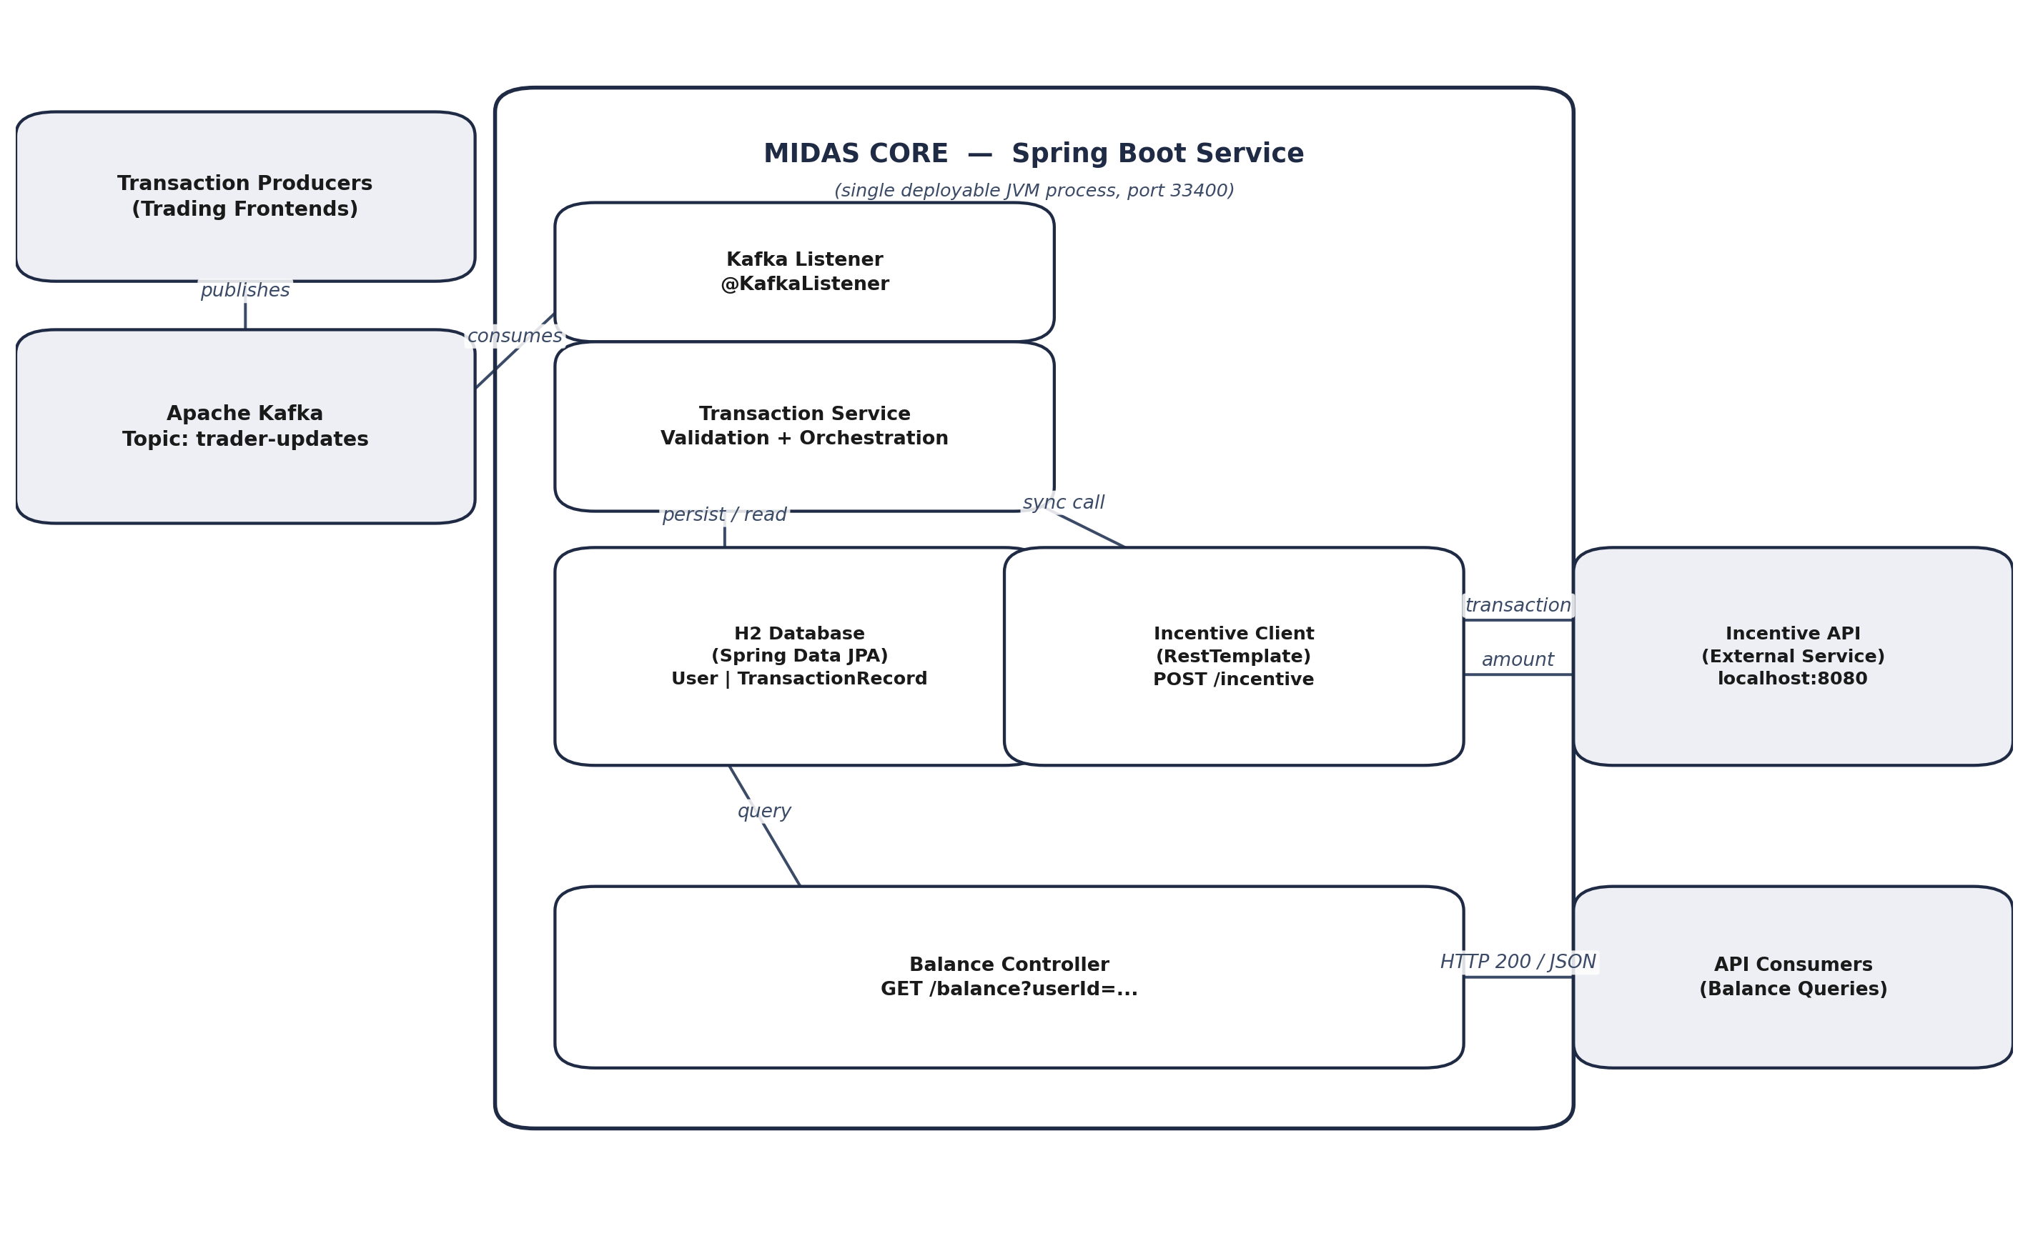
Figure 1 — Midas Core system architecture and component boundaries.

Architectural Decision Record — Balance Endpoint Placement
Option | Pros | Cons
A — Add GET /balance to Midas Core (chosen) | Minimal deployment overhead; Spring makes it trivial to add; balances live next to the data that produces them. | Slightly widens Midas Core's single-purpose responsibility.
B — Extract a new balance microservice | Cleaner separation of read and write responsibilities. | New deployment unit, new network hop, added operational overhead not justified at current scale.
Decision: Option A is adopted for the current scope. The principle applied is that architecture should balance elegance with practicality — extracting a service is justified by growth in responsibility, not by aesthetic preference. If the balance/query surface grows materially (e.g. transaction history, statements, multi-field account queries), Section 6.9 recommends revisiting this decision.

3.2 Technology Stack
Technology | Version | Purpose
Java | 17 | Core language runtime.
Spring Boot | 3.2.5 | Application framework, dependency injection, auto-configuration.
Apache Kafka | 3.1.4 (spring-kafka) | Asynchronous message broker between producers and Midas Core.
Spring Data JPA | (bundled with Spring Boot) | ORM layer for persistence of User and TransactionRecord entities.
H2 Database | 2.2.224 | In-memory relational database for development and test.
RestTemplate | (Spring Web) | Synchronous HTTP client used to call the Incentive API.
Maven | — | Build automation and dependency management.
Spring Boot Test / JUnit | 3.2.5 | Unit and integration test framework.
Testcontainers (Kafka) | 1.19.1 | Embedded Kafka broker for isolated, repeatable integration tests.

3.3 Component Design

3.3.1 Kafka Listener
Responsibility: subscribe to the configured topic (default trader-updates, injected via ${general.kafka-topic}) and deserialize each message into a Transaction object, then hand it to the Transaction Service for processing. In tests, the listener runs against an embedded Kafka broker so no external broker process is required.

3.3.2 Transaction Service
Responsibility: orchestrate the full lifecycle of a single transaction — validate against current account state, call the Incentive API, apply balance changes, and persist the result. This is the component with the highest concentration of business logic and the highest concentration of engineering risk (Section 3.9).
Validation rules enforced (must all pass):
Rule ID | Rule
VR-01 | senderId must correspond to an existing, persisted User.
VR-02 | recipientId must correspond to an existing, persisted User.
VR-03 | Sender's current balance must be greater than or equal to the transaction amount.

3.3.3 Incentive Client
Responsibility: submit a validated transaction to the external Incentive API and translate its response into an Incentive domain object. This component is the service's only outbound network dependency and is therefore the primary source of latency and failure-propagation risk (see R-01).

3.3.4 Persistence Layer (H2 + Spring Data JPA)
Responsibility: durable (for the lifetime of the process) storage of User accounts and TransactionRecord history, with Spring Data JPA repositories providing lookup and save operations. SQL was chosen over a NoSQL alternative specifically because financial data benefits from the stronger consistency and integrity guarantees a relational engine provides; JPA abstracts the concrete database so H2 can later be replaced with a production-grade engine without touching business logic.

3.3.5 Balance Controller
Responsibility: expose GET /balance?userId=... over HTTP, look up the corresponding User, and return a Balance DTO serialized to JSON. Runs on port 33400, alongside — not instead of — the Kafka listener, inside the same Spring Boot application context.

3.4 Data Model
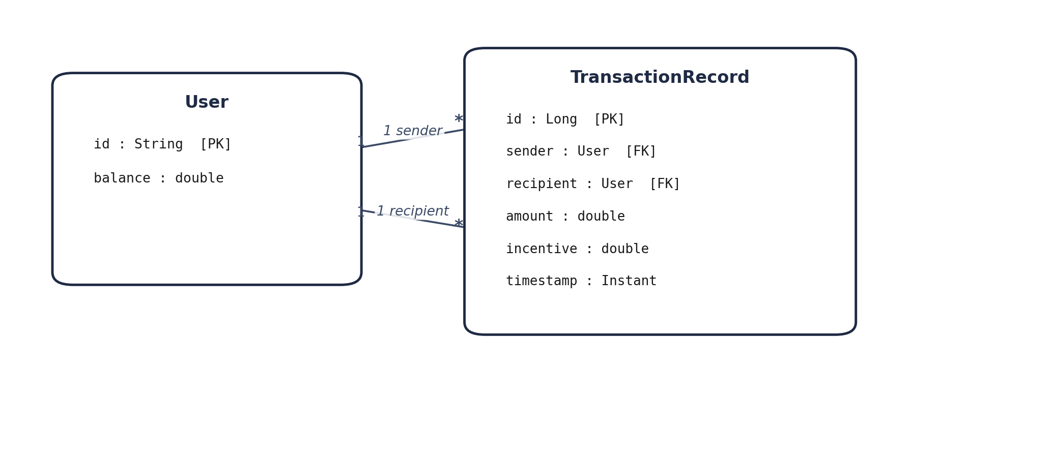
Figure 2 — Entity-relationship model. A User is referenced twice per transaction: once as sender, once as recipient.
Entity | Field | Type | Notes
User | id | String (PK) | Unique user identifier.
User | balance | double | Current account balance. See R-03 regarding monetary precision.
TransactionRecord | id | Long (PK) | Auto-generated surrogate key.
TransactionRecord | sender | User (FK, Many-to-One) | References the debited account.
TransactionRecord | recipient | User (FK, Many-to-One) | References the credited account.
TransactionRecord | amount | double | Original transaction amount (pre-incentive).
TransactionRecord | incentive | double | Amount returned by the Incentive API for this transaction.
TransactionRecord | timestamp | Instant | Recommended addition for audit trail; not in original scaffold fields.
Note: the provided Transaction class (the Kafka message DTO) is distinct from the TransactionRecord JPA entity and must not be modified — TransactionRecord is a separate persistence-layer construct introduced specifically for Task 3, per the scaffold's constraints.

3.5 API Specification

3.5.1 GET /balance — Midas Core (owned by this service)
Field | Value
Method / Path | GET /balance
Host | localhost:33400
Query Parameters | userId (string, required)
Success Response | 200 OK — JSON body matching Balance.toString() contract, e.g. { "userId": "waldorf", "amount": 128.40 }
Unknown User Response | 200 OK — Balance with amount = 0 (not a 404; this is a deliberate product decision per FR-13)
Authentication | None specified — flagged as NFR-06 / Risk R-04

3.5.2 POST /incentive — Incentive API (external, contract-only)
Field | Value
Method / Path | POST /incentive
Host | localhost:8080 (local instance run from the provided JAR)
Request Body | JSON-serialized Transaction object (senderId, recipientId, amount)
Success Response | 200 OK — { "amount": <double> }, where amount ≥ 0
Ownership | Independently maintained service — Midas Core depends only on this contract, never on its internal computation logic
Failure Handling | Not currently specified — flagged as Risk R-01 (no timeout/circuit breaker defined)

3.6 Configuration Reference (application.yml)
general: kafka-topic: trader-updates server: port: 33400 spring: datasource: url: jdbc:h2:mem:testdb driver-class-name: org.h2.Driver jpa: database-platform: org.hibernate.dialect.H2Dialect hibernate: ddl-auto: create-drop

3.7 Testing Strategy
Layer | Test Approach | Verification Artifact
Kafka ingestion | Embedded Kafka broker (Testcontainers/spring-kafka-test) publishing known messages. | TaskTwoTests — inspect first 4 deserialized transactions and confirm exact amounts.
Validation & persistence | In-memory H2, seeded users, assertions on post-transaction balances. | TaskThreeTests — inspect final balance of a named user.
Incentive integration | Local Incentive API JAR running on localhost:8080; RestTemplate call against it. | TaskFourTests — verify incentive applied only to recipient.
REST exposure | Full application context with both listener and controller active. | TaskFiveTests — HTTP call to GET /balance while listener is live.
Regression | Full Maven test suite (mvn clean install) run before each task is considered complete. | BEGIN/END console output captured per task.

3.8 Security Considerations
The current scope has no authentication, authorization, or transport-layer encryption on either the REST balance endpoint or the Incentive API integration. This is a reasonable simplification for a bounded simulation environment, but it is called out explicitly — rather than silently assumed away — because any read of this document for production planning purposes needs to treat these as open items, not settled design decisions. Concrete recommendations are captured as risk items R-04 and R-10 below.

3.9 Risk Register
The following risks are assessed against the system as specified, not as a criticism of the simulation's scope — several are explicitly out of scope for the learning exercise (Section 2.11) but are documented here because a TRD that omits known weaknesses is incomplete by definition.
ID | Risk | Impact | Likelihood | Mitigation
R-01 | Incentive API is called synchronously on the critical path with no timeout or circuit breaker; an unresponsive dependency stalls all transaction processing. | High | Medium | Add an explicit HTTP timeout, a circuit breaker (e.g. Resilience4j), and a defined fallback (queue-and-retry or reject with reason).
R-02 | No idempotency key or deduplication; Kafka redelivery (consumer restart, rebalance) can cause a transaction to be processed twice, double-debiting the sender. | High | Medium | Introduce an idempotency key (e.g. message offset or transaction UUID) with a uniqueness constraint, and commit the DB write before acknowledging the Kafka offset.
R-03 | Monetary amounts use double; binary floating-point cannot represent all decimal currency values exactly, risking rounding drift over many transactions. | Medium-High | High | Migrate amount, balance, and incentive fields to BigDecimal with a fixed scale and defined rounding mode.
R-04 | GET /balance has no authentication; any caller can query any user's balance. | High | High (if exposed beyond localhost) | Add authentication (API key, OAuth2/JWT) and authorization scoped to the requesting identity; restrict network exposure.
R-05 | H2 runs in-memory; all account and transaction data is lost on process restart, with no durability guarantee. | High (production) / Low (dev-test) | High | Use a durable RDBMS (e.g. PostgreSQL) in any non-development profile; keep H2 for local/test profiles only.
R-06 | No dead-letter handling for malformed Kafka messages; a poison message can be silently dropped or crash the listener thread. | Medium | Low-Medium | Wrap deserialization in explicit error handling and route unparseable messages to a dead-letter topic for later inspection.
R-07 | Balance read-modify-write is not explicitly protected against concurrent transactions on the same account, risking a lost-update race condition. | High | Medium (rises with throughput) | Use optimistic locking (@Version on User) or a database-level transaction with row-level locking around balance updates.
R-08 | No structured logging, metrics, or tracing is defined; diagnosing a production incident would be difficult. | Medium | High | Add structured logging, Micrometer-based metrics, and distributed tracing before any non-development deployment.
R-09 | Validation rules do not explicitly reject a zero or negative transaction amount. | Medium | Medium | Add an explicit amount > 0 rule to the validation set (VR-04).
R-10 | The Incentive API is an external black box; a malformed or out-of-bounds response (e.g. an unexpectedly large amount) is applied without a sanity check. | Medium | Low-Medium | Validate incentive.amount against a defined upper bound before applying it to the recipient's balance.

4. Part III — System Interaction Flow
Why this section replaces a traditional UI/UX flow
Midas Core is a headless backend service — it has no screens, no user interface, and no visual design surface. Producing wireframes or click-through flows for it would misrepresent the system rather than document it. The industry-standard equivalent for a backend/API service is a system interaction flow: the sequence in which components exchange data, and the request/response "experience" presented to the API consumers who are this system's actual users. That is what this section documents.

4.1 End-to-End Interaction Sequence
The diagram below traces a single valid transaction from publication through to its effect on both accounts. This is the primary flow the system is designed around.
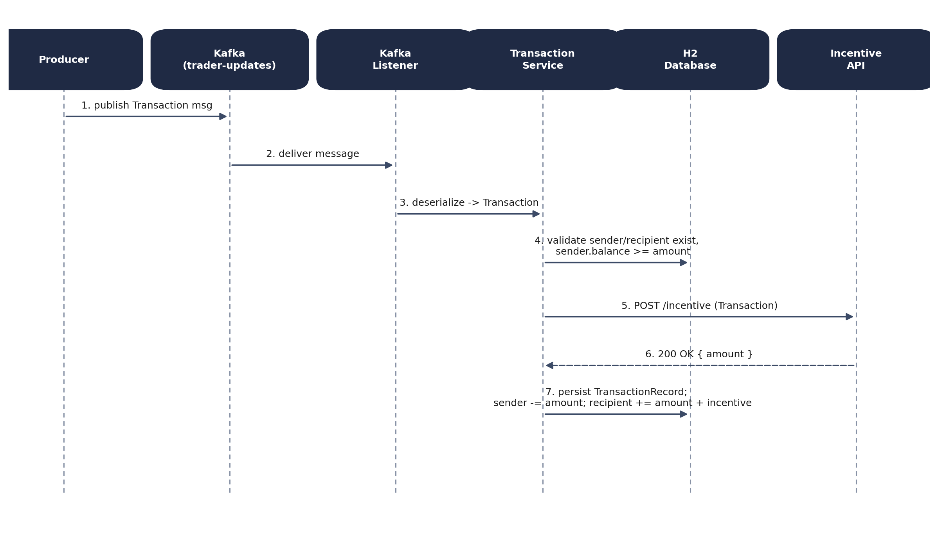
Figure 3 — Sequence of a valid transaction, from Kafka publication to persisted balance update.

4.2 Transaction State Model
Although Midas Core has no persisted "status" field on a transaction, every transaction implicitly passes through the following states. Making them explicit is useful both for testing and for any future audit/logging work (Risk R-08).
State | Trigger | Next State(s)
Received | Kafka listener deserializes the message. | Validating
Validating | Transaction Service checks VR-01, VR-02, VR-03. | Rejected (any rule fails) or Enriching (all pass)
Rejected | Any validation rule fails. | Terminal — discarded, no persistence, no balance change
Enriching | POST sent to Incentive API. | Enriched (200 OK) or Failed (timeout/error — currently unhandled, see R-01)
Enriched | Incentive amount received. | Persisted
Persisted | TransactionRecord saved; sender/recipient balances updated. | Terminal — queryable via GET /balance

4.3 API Consumer Experience — Success Path
Request
GET http://localhost:33400/balance?userId=waldorf
Response — 200 OK
{ "userId": "waldorf", "amount": 128.40 }

4.4 API Consumer Experience — Exception Paths
Scenario | System Behavior | Consumer-Facing Result
Unknown userId queried at GET /balance | User lookup returns no result; controller returns a Balance with amount = 0 rather than an error. | 200 OK, { "userId": "unknown", "amount": 0.0 } — deliberate, per FR-13.
Transaction references a non-existent sender or recipient | VR-01 / VR-02 fails; transaction is discarded before persistence. | No consumer-facing response — Kafka has no request/reply; the transaction is silently dropped (see R-06 regarding lack of dead-letter visibility).
Sender balance insufficient for the amount | VR-03 fails; transaction is discarded before persistence. | Same as above — no error surfaced to the producer under current design.
Incentive API is unreachable or slow | Not currently handled — the synchronous call blocks; behavior is undefined beyond the default HTTP client timeout. | Delayed or failed processing of the entire transaction, with no isolation from other in-flight transactions (Risk R-01).

4.5 Balance Query — Concurrent Operation
Because the REST controller and the Kafka listener share the same Spring Boot process and the same persistence context, a GET /balance call can legitimately be served while the listener is actively processing other transactions. FR-14 requires this to work correctly; Section 3.9 (R-07) flags the specific concurrency risk this introduces when two transactions touch the same account at overlapping times.

5. Part IV — Implementation Plan

5.1 Delivery Approach
Delivery follows the five-task structure defined by the program scaffold, treated as five sequential, independently testable increments. Each task has a clear entry condition (the previous task's tests passing), a bounded set of new classes/config, and its own automated verification suite. This mirrors a standard incremental delivery approach: ship a thin vertical slice, verify it, then extend.

5.2 Work Breakdown Structure
Phase | Deliverable | Key Activities | Effort | Depends On
Phase 0 Task 1 | Environment & scaffold ready | Fork/clone repo; configure Java 17; add Maven dependencies; configure application.yml; run baseline build. | 0.5 day | —
Phase 1 Task 2 | Kafka ingestion working | Implement @KafkaListener; bind topic via config; deserialize into Transaction; verify against embedded Kafka. | 1 day | Phase 0
Phase 2 Task 3 | Validation & persistence working | Define TransactionRecord entity and User relationships; implement VR-01–VR-03; implement balance debit/credit; verify via debugger. | 1.5 days | Phase 1
Phase 3 Task 4 | Incentive enrichment working | Implement Incentive DTO and client; call POST /incentive via RestTemplate; apply incentive to recipient only. | 1 day | Phase 2
Phase 4 Task 5 | Balance API exposed | Implement BalanceController; configure port 33400; verify concurrent operation with listener. | 0.5 day | Phase 3
Phase 5 (Recommended, beyond current brief) | Production-readiness hardening | Address Risk Register items R-01–R-10: timeouts/circuit breaker, idempotency, BigDecimal migration, auth, structured logging. | 2–3 days | Phase 4
Phase 5 is not part of the original five-task brief; it is included because a document claiming industry-standard completeness should not stop at "tests pass" without naming what production hardening would require.

5.3 Timeline
Day | Focus
Day 1 | Phase 0 — environment setup and baseline build verification.
Day 2 | Phase 1 — Kafka listener implementation and TaskTwoTests passing.
Day 3–4 | Phase 2 — entity modeling, validation logic, TaskThreeTests passing.
Day 5 | Phase 3 — Incentive API integration, TaskFourTests passing.
Day 6 | Phase 4 — REST controller, TaskFiveTests passing, full regression run.
Day 7 | Buffer, documentation, and review.
Day 8–10 (optional) | Phase 5 — hardening items, if scope is extended beyond the simulation brief.

5.4 Roles and Responsibilities (RACI)
This simulation is completed by a single contributor, who fulfills the Developer and QA roles concurrently. The RACI matrix below is provided as the standard project artifact and reflects how responsibility would be distributed on a staffed team.
Activity | Product Owner | Tech Lead / Developer | QA / Reviewer
Requirements sign-off (PRD) | A | C | I
Architecture & design (TRD) | I | A / R | C
Implementation (Tasks 1–5) | I | A / R | I
Test execution & verification | I | R | A
Risk register review | C | R | A
R = Responsible, A = Accountable, C = Consulted, I = Informed.

5.5 Definition of Done
- All five task-specific automated test suites pass (mvn clean install green end to end).
- BEGIN/END console output captured for each task per program submission requirements.
- Sender and recipient balances verified correct via debugger inspection for the required scenarios.
- Incentive amount confirmed applied to recipient only, never to sender.
- GET /balance verified functioning correctly while the Kafka listener is concurrently active.
- Transaction, Balance.toString(), and other scaffold-provided contracts left unmodified.
- This document's Risk Register reviewed and consciously accepted or scheduled, not silently ignored.

5.6 Deployment and Environment Strategy
The current scope targets a local development/test environment only: H2 in-memory database, embedded Kafka for tests, and the Incentive API JAR run manually from services/. No CI/CD pipeline, containerization, or cloud deployment target is defined in this simulation. For any real deployment beyond the simulation, the standard next steps would be: containerize the service, externalize configuration per environment (dev/staging/prod), replace H2 with a managed relational database, and stand up the Incentive API as an independently deployed and versioned service — all consistent with the architecture already established in Section 3.1.

5.7 RAID Log
Open questions from the initial project-understanding phase are tracked here as a formal RAID log (Risks, Assumptions, Issues, Dependencies) rather than left as an informal checklist, so that each item has an explicit owner and status.
ID | Type | Description | Owner | Status
RAID-01 | Issue | Unconfirmed whether the provided scaffold already includes a User entity annotated with @Entity, or whether it must be authored from scratch. | Developer | Open
RAID-02 | Dependency | Unconfirmed whether a data.sql seed file for initial user data is provided, or must be authored for tests to have accounts to reference. | Developer | Open
RAID-03 | Assumption | Transaction class is assumed to contain, at minimum, senderId, recipientId, and amount; exact field set (including any timestamp) to be confirmed against the scaffold. | Developer | Open
RAID-04 | Dependency | Incentive API JAR is assumed to be pre-built and included under services/ in the cloned repository. | Developer | Open
RAID-05 | Issue | Unconfirmed whether the scaffold includes any partially implemented service classes that must be completed rather than authored new. | Developer | Open
RAID-06 | Risk | See Section 3.9, Risk Register (R-01 through R-10) for all identified technical risks. | Tech Lead | Tracked

5.8 Rollback and Contingency
Because each of the five tasks is independently verifiable and additive, the natural rollback unit is the task boundary: if a given task's tests fail and cannot be resolved within the planned effort, work reverts to the last task with a fully green test suite, and that state is treated as the deliverable baseline while the failing task is revisited. This avoids a partially-working, unverifiable intermediate state ever being treated as "done."

6. Appendices

6.1 Glossary
Term | Definition
DTO | Data Transfer Object — a plain object used to move data between layers or across a network boundary, without persistence behavior.
Entity | A class annotated for JPA persistence, mapped to a relational database table.
Idempotency | A property whereby performing an operation multiple times has the same effect as performing it once — relevant to safe handling of redelivered Kafka messages.
Kafka Topic | A named, partitioned log to which producers publish and from which consumers read messages asynchronously.
RestTemplate | Spring's synchronous HTTP client, used here to call the external Incentive API.
Testcontainers | A library that provisions throwaway, real infrastructure (e.g. an embedded Kafka broker) for integration tests.
Circuit Breaker | A resilience pattern that stops calls to a failing dependency for a cool-down period, preventing cascading failure.

6.2 Reference Documents
- Scaffold repository: https://github.com/vagabond-systems/forage-midas
- Program: Forage × JPMorganChase Software Engineering Virtual Internship
- Source input: Project_Understanding_Draft.md, Phase 1 — Documents & Designing

6.3 Key Domain Classes
Class | Type | Description
Transaction | DTO | Incoming Kafka message payload: senderId, recipientId, amount. Provided by the scaffold; not to be modified.
TransactionRecord | JPA Entity | Persisted transaction, with Many-to-One relationships to sender and recipient User entities.
User | JPA Entity | Account holder with an id and a balance; One-to-Many owner of its associated transactions.
Incentive | DTO | Response payload from the Incentive API — a single amount field.
Balance | DTO | Response payload for GET /balance; its toString() output is used for automated test verification.

6.4 Software Engineering Principles Applied
Principle | Where Applied
Separation of Concerns | Kafka ingestion, persistence, external integration, and REST exposure are kept as distinct components.
API as a Contract | The Incentive API boundary lets two teams work independently as long as its request/response schema holds.
Avoid Premature Over-Engineering | The balance endpoint is added to Midas Core rather than extracted into a new service prematurely (Section 3.1).
Abstraction via ORM | JPA decouples business logic from the concrete database engine, enabling a production swap without code changes.
Asynchronous, Resilient Ingestion | Kafka decouples producer availability from Midas Core's own uptime and absorbs bursty load.
SQL for Financial Data | A relational engine is chosen over NoSQL specifically for the stronger consistency guarantees financial state requires.
Test-Driven Verification | Every task has a dedicated, automated test suite gating completion.

End of Document

